MIBOOKO Launches AI Storybook Platform Guided by Child-Development Science
Built with early-childhood specialists, MIBOOKO offers safer, age-tailored storybooks that help families nurture children’s confidence, empathy, and resilience.

WARSAW, Poland - December 3rd, 2025 - As parents globally confront rising concerns about the quality, safety, and developmental suitability of AI-generated content for children, MIBOOKO today announced the international launch of its personalized storytelling platform — the first to combine advanced AI with child-development science and expert-reviewed emotional frameworks. The service generates fully illustrated, age-appropriate storybooks tailored to each child’s personality, emotional needs, and developmental stage, offering families a reliable alternative to generic AI tools flooding the market.
Unlike traditional personalized books that primarily swap a child’s name into a static template, MIBOOKO’s story engine dynamically adapts narrative tone, pacing, themes, and character arcs to support specific childhood growth milestones. The platform was designed in collaboration with early-childhood specialists, ensuring that stories remain emotionally supportive and aligned with the psychological needs of children across different developmental stages — from toddlers discovering early language to older children navigating confidence, social challenges, or new experiences. This foundation gives families a powerful ritual for strengthening connection, boosting confidence, and helping children understand and process their feelings through safe, meaningful narratives.
A New Standard for AI Storytelling
MIBOOKO arrives at a pivotal moment. With AI tools rapidly proliferating, parents report difficulty distinguishing between high-quality, developmentally appropriate content and outputs that may be inconsistent, emotionally flat, or even unsafe. Parents increasingly express uncertainty about whether generic AI tools can produce content that is consistently age-appropriate or emotionally suitable. MIBOOKO’s approach directly addresses this challenge, positioning the platform as a premium standard-bearer in the next generation of EdTech storytelling.
MIBOOKO’s engine incorporates layered safeguards:
• developmentally informed tone controls
• moral and emotional relevance checks
• age-stage narrative coherence
• consistent illustration guidance based on stable character modeling
This ensures that each story supports foundational skills such as empathy, imaginative thinking, emotional regulation, and perspective-taking — capacities that psychologists identify as essential in childhood development.
Key Features of the MIBOOKO Platform
• Deep Personalization: Story adaptation based on age, personality traits, challenges, and developmental goals
• Consistent Illustration System: Unified art direction for high-quality, cohesive visuals, avoiding randomness typical of generative tools
• Two Avatar Creation Modes:
o Photo-based: Parents may upload a child’s photo to generate an accurate avatar
o Privacy-first mode: A guided step-by-step character builder for families who prefer not to upload images
• Parent Voiceover: Turn any story into a personal audiobook narrated by a caregiver’s voice
• <2-Minute Creation Flow: A simple six-step builder accessible to non-technical users
• Digital Formats for Devices + Home Printing
• Global Availability in 10+ Languages: English, Polish, Spanish, French, German, Russian, Portuguese, Turkish, Italian, Korean, with more coming
• Evidence-Based Story Themes: Confidence, courage, friendship, focus, emotional resilience, managing fears, new experiences, and more
Founder Vision
“Every child deserves a story that reflects their potential — not just their name,” said Artur Derwiszynski, Co-founder of MIBOOKO. “When children recognize themselves in a story, something profound happens: reading becomes connection, imagination becomes confidence, and bedtime becomes an emotional anchor. MIBOOKO was created to help families build those moments with tools that are safe, personal, and guided by real developmental science.”
Derwiszynski continued:
“Most personalized books merely swap a name into a prewritten text or produce smiling avatars without deeper coherence. We built MIBOOKO to deliver author-level narrative structure and consistent illustrations, all grounded in child-development research. The goal is not mass content — it’s meaningful content.”
Expert Perspective
“Psychology-based personalization marks a major step forward in EdTech,” said an early-childhood development specialist who contributed to the project. “MIBOOKO adapts narrative structure to support specific developmental traits — from empathy and resilience to emotional self-regulation — ensuring stories are engaging and developmentally constructive. This level of intentionality is rarely present in generic AI content, which often lacks age relevance or emotional scaffolding.”
The expert added:
“When children feel represented, they return to stories multiple times — which is exactly how emotional learning is reinforced.”
Why Personalized Stories Matter Now
A major meta-analysis of 63 studies involving 11,413 children aged six and under found that e-books significantly outperform other screen media in supporting vocabulary development. Additional research shows that interactive and personalized story formats can enhance engagement, comprehension, and emotional processing — reinforcing the power of well-designed digital narratives.
Modern families also face structural challenges:
• reduced reading time
• higher emotional pressure on children
• increased digital overstimulation
• fragmented family schedules
MIBOOKO addresses these issues by making meaningful reading rituals accessible. Within minutes, families can generate a story designed to support their child through real-life situations — starting school, managing fears, adjusting to changes, or building confidence.
Market Context: A Shift Toward Safe, Guided AI
As the AI content landscape expands, experts warn that without oversight, narrative outputs can become inconsistent, overly mature, or emotionally off-target. MIBOOKO’s approach — combining AI with human developmental guidance, cultural adaptation, and strict safety guardrails — offers a middle path between full automation and traditional book publishing.
Internal evaluations show MIBOOKO outperforming major competitors on metrics including:
• age appropriateness
• narrative clarity
• emotional depth
• illustration consistency
• safety compliance
All assessments scored five stars in controlled internal testing.
Availability
MIBOOKO is now available worldwide. Stories are delivered digitally, ready for mobile viewing, tablet reading, or at-home printing. The platform also supports optional parent voiceover, multilingual delivery, and — coming soon — worldwide shipping of softcover and hardcover printed books.
For Journalists
Journalists, reviewers, and analysts are welcome to request:
• high-resolution visuals & sample story pages
• interview scheduling with the founder
This press release, along with press materials and the full media kit, is available in Polish, German, French, and Spanish at https://mibooko.com/press/
Media inquiries: press@mibooko.com
About MIBOOKO
MIBOOKO™ creates premium personalized storybooks designed to support children’s emotional, cognitive, and language development across diverse life stages. Each title integrates cinematic illustrations, developmental psychology, and simple customization tools to support emotional growth, literacy, and family connection. MIBOOKO’s mission is to transform reading time into a meaningful ritual of imagination, empathy, and resilience-building.
Learn more at https://mibooko.com
video:

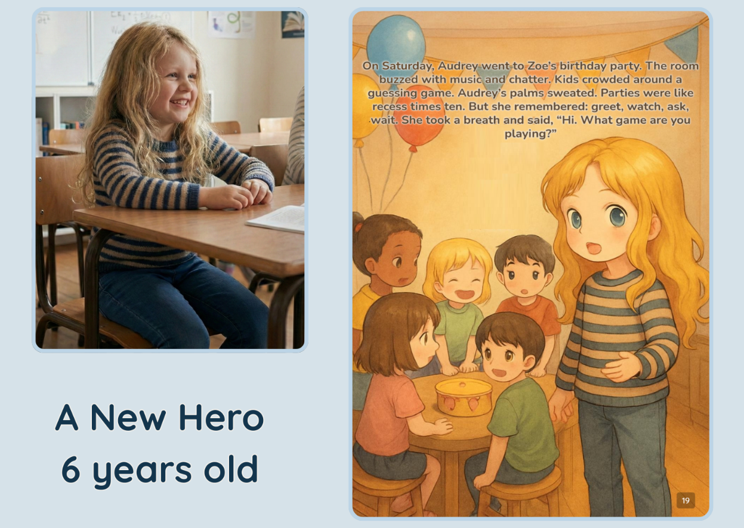
Name of the file: mibooko_personalized_story_example_child_to_storybook
Caption: A MIBOOKO example showing how a child can appear as the hero of their own illustrated storybook, reflecting real-life experiences through personalized storytelling.

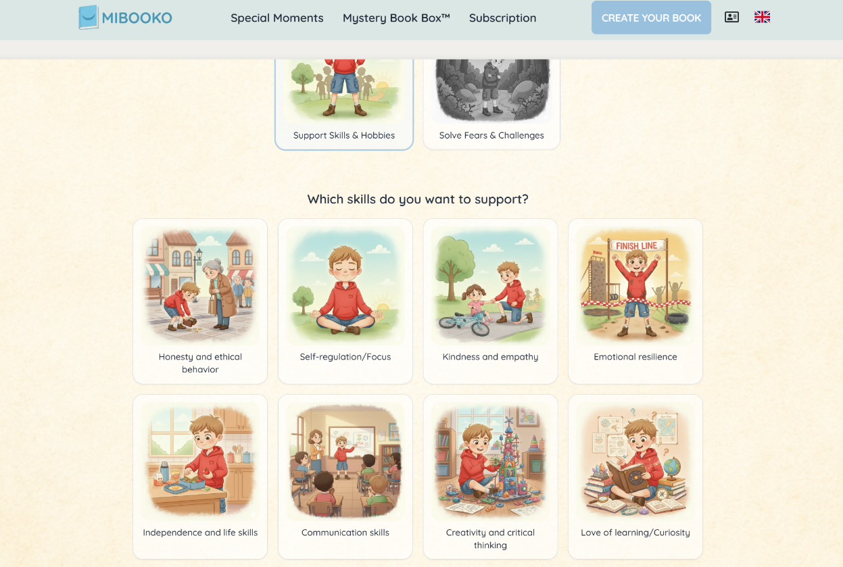
name: mibooko_story_configurator_skills_interface
Caption: Screenshot of the MIBOOKO personalization interface, where families select the emotional and developmental skills they want a child’s storybook to support.

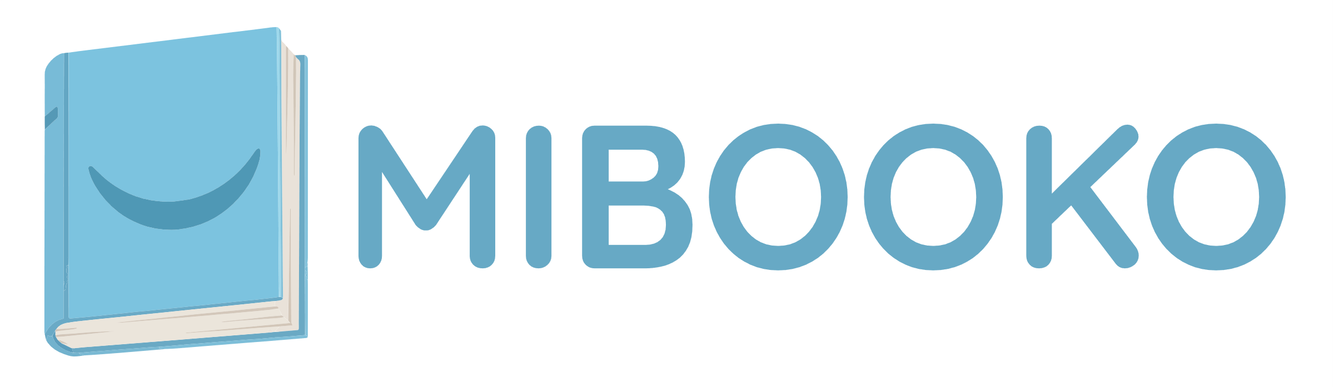

Name: mibooko_personalized_storybooks_logo
Caption: Official MIBOOKO logo representing the personalized children’s storybook platform.

